Protocol IR and WNV testing in Culex spp.
Description: The aim of the protocol is to describe steps 1. homogenization of mosquito bodies for 2. viral RNA extraction and 3. testing of West Nile (WNV) and Usutu (USUV) viruses, followed by 4. genomic DNA extraction for the purpose of 5. insecticide resistance testing (IR) in Culex spp. mosquitoes. These procedures are prerequisites for NGS sequencing.

Homogenization
Mosquitoes are stored in a -80°C freezer.
1. Place individual mosquitoes into a 2 ml rounded SAFE Lock Eppendorf tube (sterile).
2. Add one 5 mm stainless bead into each tube using the bead dispenser.
3. Add 500 μL sterile 7.2 pH cooled PBS into each tube.
4. Homogenate in Tissue Lyser 2 (Qiagen, Germany) set up for 30 Hz, 1 min.
6. After homogenization, centrifuge in a pre-cooled centrifuge at 2000 rpm for 10 min, 4 °C.
7. Work gently with the tubes after centrifugation; do not disturb the sediment.
Label 3 clear 1,5 ml Eppendorf tubes per sample, and aspirate clear supernatant :
- Sample name, date, type - homogenate, DNA - 180 ul
- Sample name, date, type - homogenate, RNA - 140 ul
- Sample name, date, type - homogenate - 180 ul (or less, try to aspirate only clear supernatant)
Store tube 1. (DNA) and 3. (homogenate) immediately at -80 C.
Start work with tube 2, RNA extraction.

2. RNA extraction
Kit: QIAamp mini viral RNA kit (Cat. nº 52906).
Centrifuge set on 25 C.
1. Pipet 560 μL prepared Buffer AVL into tube 2 and mix by pipetting 10 times.
2. Incubate for 10 minutes at room temperature.
3. Add 560 μL ethanol (96–100% molecular grade) to the sample, and mix by pulse-vortexing for 15 s. After mixing, briefly centrifuge the tube.
4. Add 630 μl of mixture to a spin column in a clean 2 ml collection tube. Centrifuge for 1 minute at 8000 rpm). Place the spin column in a new collection tube and discard the previous one with the flow-through.
5. Repeat the previous step with the rest of the initial mixture to the same spin column.
6. Add 500 μl of Buffer AW1 to the spin column. Centrifuge for 1 minute at 8000 rpm. Place the spin column in a new collection tube and discard the previous one with the flow-through.
7. Add 500 μl of Buffer AW2 to the spin column. Centrifuge for 3 minutes at full speed 14,000 rpm. Place the spin column in a new collection tube and discard the previous one with the flow-through.
8. Centrifuge for 1 minute at 8000 rpm to dry silica membrane.
8. Place the spin column in a new 1.5 ml collection tube. Add 60 μl nuclease free water directly onto the spin column membrane. Incubate for 1 minute at room temperature. Centrifuge for 1 minute at 8000 rpm to elute the RNA.
Store RNA at -80 °C or proceed to Real-time qPCR for WNV and USUV immediately.

3. Real-time qPCR WNV and USUV
Kit: GoTaq - Promega One Step Probe RT-qPCR kit.
The master mix for WNV and USUV is prepared separately for 28 wells (24 samples, negative control, positive control, plus 2 extra samples.
Reagents | X1 (μl) | X28 (per virus)
GoTaq 2X | 10 | 280
H₂O | 1.6 | 44.8
Primer forward | 1 | 28
Primer reverse | 1 | 28
Probe | 1 | 28
GoScript | 0.4 | 11.2
Template | 5 | -

Cycling conditions (in Quantstudio 5, Thermo Fisher Scientific) are as follows:
Time | Temperature | Cycles
10 min | 55°C | 1
10 min | 95°C | 1
15 s | 95°C | 45
30 s | 60°C

Channels should be set as: FAM for signal acquisition and TAMRA for quencher option in the QuantStudio 5 software.

DNA extraction
Kit: DNeasy Blood & Tissue DNA kit (Qiagen)
1. Thaw tubes nr. 1 - aliquots for DNA extraction at RT.
2. Add 180 μl of ATL buffer and 20 μl of Proteinase K into each tube (can be premixed in falcon tubes and aliquoted into each tube). Vortex for 5-10s.
3. Incubate at 56 C, for 2 h.
4. Spin down
5. Mix 5.2 ml of Buffer AL and 5.2 ml of ethanol (96-100%) (recommended for multiple samples, in this case enough for 26).
6. Add 400 µl of Buffer AL-Ethanol solution per sample. Vortex immediately. Spin down
7. Pipette mixture into DNeasy Mini spin columns in 2 ml collection tubes (provided). Centrifuge 1 min (8000 rpm). Discard flow-through and collection tubes.
8. Place columns into new collection tubes. Add 500 µl Buffer AW1 per column. Centrifuge 1 min (8000 rpm). Discard flow-through and collection tube.
9. Place columns into new collection tubes. Add 500 µl Buffer AW2 per column. Centrifuge 3 min (14,000 rpm). Discard flow-through and tubes.
10. Place the column into a clean 1.5 ml Eppendorf. Add 100 µl nuclease free water directly onto the membrane.
11. Incubate 1 min at room temperature.
12. Centrifuge 1 min (8000 rpm). Store Eppendorf and respective flow-through at -20°C, or start with PCR immediately.

Insecticide Resistance – VGSC (1014F)/kdr
Allele-Specific PCR for Pyrethroid Resistance in Culex pipiens
Target Gene
The voltage-sensitive sodium channel gene (vssc) mutation L1014F is associated with pyrethroid resistance. Two separate PCR reactions are performed to detect susceptible and resistant alleles.
Primers
Primer | Sequence (5′–3′) | Direction
Cgd1 | GTGGAACTTCACCGACTTC | Forward
Cgd2 | GCAAGGCTAAGAAAAGGTTAAG | Reverse (common)
Cgd3 | CCACCGTAGTGATAGGAAATTTA | Reverse (susceptible)
Cgd4 | CCACCGTAGTGATAGGAAATTTT | Reverse (resistant)
PCR Reaction – Susceptible Allele Detection
Primers: Cgd1 + Cgd2 + Cgd3
Master Mix (per reaction):
Component | Volume (µl)
DreamTaq™ Hot Start Green PCR Master Mix (K9022) | 12.5
Nuclease-free water (H₂O) | 4.5
Primer Cgd1 (10 µM) | 1.0
Primer Cgd2 (10 µM) | 1.0
Primer Cgd3 (10 µM) | 1.0
Total Volume | 20.0
+ DNA Template | 5.0
PCR Reaction – Resistant Allele Detection
Primers: Cgd1 + Cgd2 + Cgd4

Master Mix (per reaction):
Component | Volume (µl)
DreamTaq™ Hot Start Green PCR Master Mix (K9022) | 12.5
Nuclease-free water (H₂O) | 4.5
Primer Cgd1 (10 µM) | 1.0
Primer Cgd2 (10 µM) | 1.0
Primer Cgd4 (10 µM) | 1.0
Total Volume | 20.0
+ DNA Template | 5.0

Thermal Cycler Conditions (Both Reactions)
Initial Denaturation: 95 °C for 3 min
Denaturation: 95 °C for 30 s
Annealing: 52 °C for 30 s
Extension: 72 °C for 1 min
Cycles: Repeat above 3 steps × 40 cycles
Final Extension: 72 °C for 10 min
Hold: 4 °C indefinitely

Result Interpretation (Gel Electrophoresis)
Use 100 bp DNA ladder (e.g., Promega). Visualize PCR products to determine genotype:
Genotype | Band in Susceptible Reaction (Cgd3) | Band in Resistant Reaction (Cgd4) | Interpretation
SS (wild type) | 354–383 bp | – | Homozygous susceptible
SR (heterozygote) | 354–383 bp | 354–383 bp | Heterozygote
RR (mutant) | – | 354–383 bp | Homozygous resistant
Control band | 481–510 bp (optional internal control) | 481–510 bp (if used) | Confirms amplification

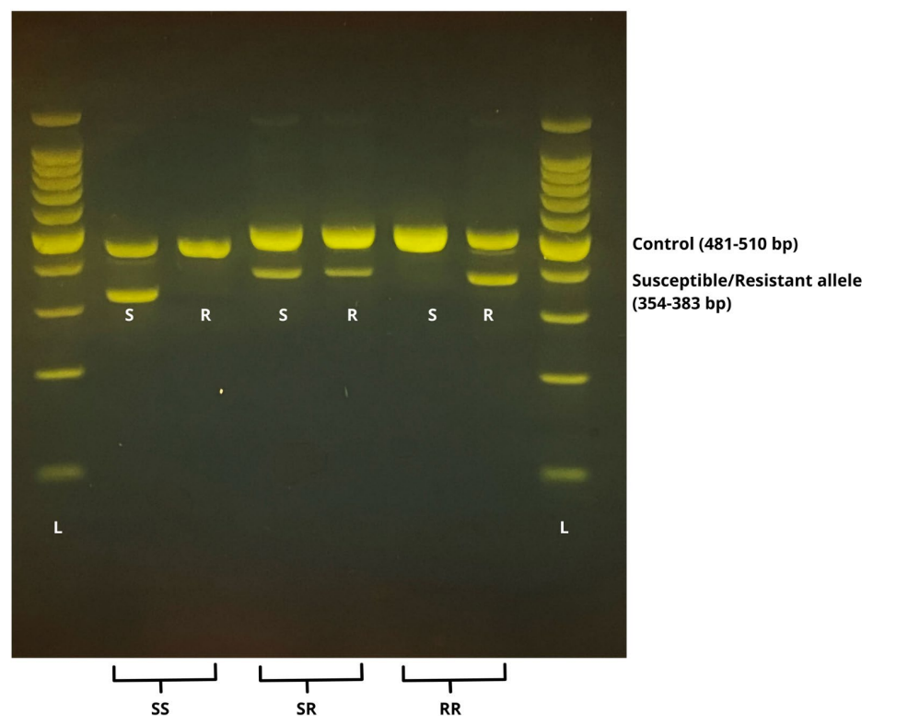
Representative electrophoretic profiles of the allele-specific diagnostic PCR assay for detecting the kdr mutation L1014F in Culex pipiens. In the case of each sample, two parallel PCR reactions were made with primers amplifying the control (481–510 bp), the susceptible (S), and/ or the resistant (R) alleles (354-383 bp) from genomic DNA (L: 100 bp ladder (Promega, Wisconsin, USA), genotypes of homozygote susceptible (SS),heterozygote (SR), and homozygote resistant (RR) mosquitoes)

References
Martinez-Torres D, Chevillon C, Brun-Barale A, Bergé J, Pasteur N, Pauron D. Voltage-dependent NA+ channels in pyrethroid-resistant Culex pipiens L. mosquitoes. Pest Sci. 1999;55(10):1012–20.
Csiba, R., Varga, Z., Pásztor, D. et al. Consequences of insecticide overuse in Hungary: assessment of pyrethroid resistance in Culex pipiens and Aedes albopictus mosquitoes. Parasites Vectors 18, 13 (2025). https://doi.org/10.1186/s13071-024-06635-5

